101 Problems Assignment

Using Scratch, create a design of at least six items using two different shapes.

- Go to Scratch and log in. You can create a new program by selecting Create.
- Change your sprite and background.
- Create two different functions that draw shapes with size parameters.
- Create two variables that will keep a count of how many of each shape are in the program. Add the change variables by 1 block to each of the shape functions you created.
- Create a code block that
  - starts when the green flag is selected
  - sets both variables to 0
  - draws a design of at least 6 shapes by calling your shape functions
    - use different parameters for size for each of the 6 shapes
- Save your file to your computer to submit for grading.

Examples of what your program might include:

Functions | 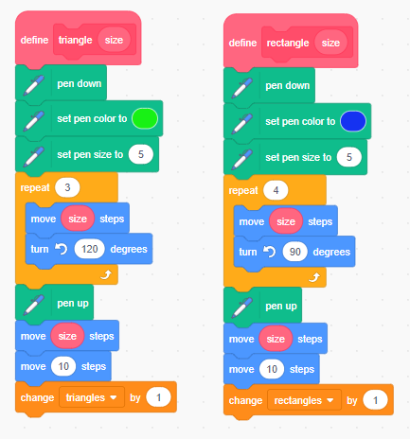
Code Block | 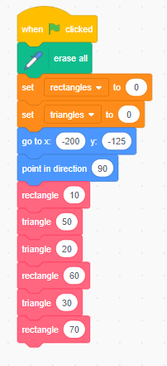
Screen | 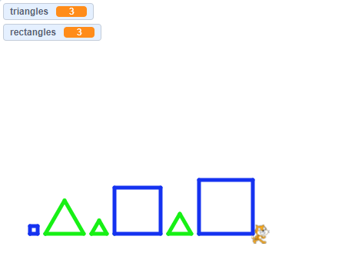

Grading Rubric

Criteria | Excellent | Good | Needs Improvement
Program Design | 11–20 points  Work contains all required elements:  - includes one sprite that was not part of the starter program  - includes a background that was not part of the starter program  - includes two different functions that draw shapes with size parameters  - includes two variables that keep count of how many of each shape there are in the program | 6–10 points  Work contains most of the required elements:  - includes one sprite that was not part of the starter program  - includes a background that was not part of the starter program  - includes two different functions that draw shapes with size parameters  - includes two variables that keep count of how many of each shape there are in the program | 0–5 points  Work contains a few of the required elements:  - includes one sprite that was not part of the starter program  - includes a background that was not part of the starter program  - includes two different functions that draw shapes with size parameters  - includes two variables that keep count of how many of each shape there are in the program
Program Content | 11–20 points  Work contains all required elements:  - program contains a code block that starts when the green flag is selected  - both variables are set to 0  - draws a design of at least six shapes by calling the shape functions  - uses different parameters for size for each of the six shapes | 6–10 points  Work contains most of the required elements:  - program contains a code block that starts when the green flag is selected  - both variables are set to 0  - draws a design of at least six shapes by calling the shape functions  - uses different parameters for size for each of the six shapes | 0–5 points  Work contains a few of the required elements:  - program contains a code block that starts when the green flag is selected  - both variables are set to 0  - draws a design of at least six shapes by calling the shape functions  - uses different parameters for size for each of the six shapes
Program Performance | 8–10 points  Work contains all required elements:  - the program runs correctly  - the program contains no syntax or runtime errors  - the program produces the expected results | 4–7 points  Work contains most of the required elements:  - the program runs correctly  - the program contains no syntax or runtime errors  - the program produces the expected results | 0–3 points  Work contains a few of the required elements:  - the program runs correctly  - the program contains no syntax or runtime errors  - the program produces the expected results
Total points: 50

