3.03 Show Me the Code!
Step 1
​Start off your project the same way you did with 1.04 and 2.02: head to the Scratch website or your desktop Scratch app and login. Then, click "Create" to start a new program.
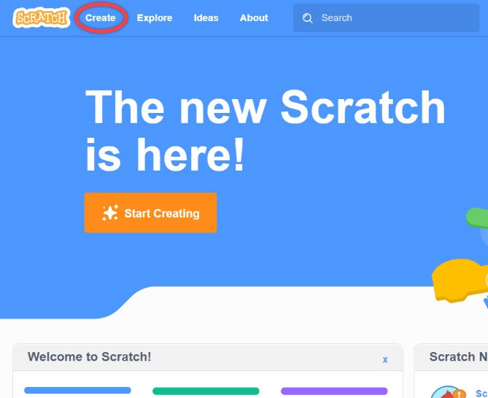
Step 2
Since this is a quiz, it makes sense to start with the questions! Decide on three simple questions for a chosen topic.
Example: What is the capital of Georgia? Answer: Atlanta
Hint: Having questions with very short or even one-word answers will reduce the number of errors you’ll need to fix, as well as the troubleshooting you’ll need to do, later on!
Step 3
Armed with your questions in hand and a new program queued up, add a new sprite that will host the game.
Hint: Here’s a chance to show off your creativity! Try to choose a fun sprite to be a host and change up your background to match.
Step 4
Use the following steps to write the code for your game.
- Start the program by clicking on the green flag
- Trivia quiz host asks question number 1.
Example: What is the capital of Georgia?
- User enters a response into the input box.
- User input is stored in a variable called: answer.
- Check to see if the user’s response is the correct answer. Note that the answer will need to be with correct capitalization.
  - If correct, the quiz says: Good job. That’s correct.
  - If not correct, the quiz says: That is incorrect. The correct answer is Atlanta.
- Repeat steps 3–6 for until you have three questions or more.
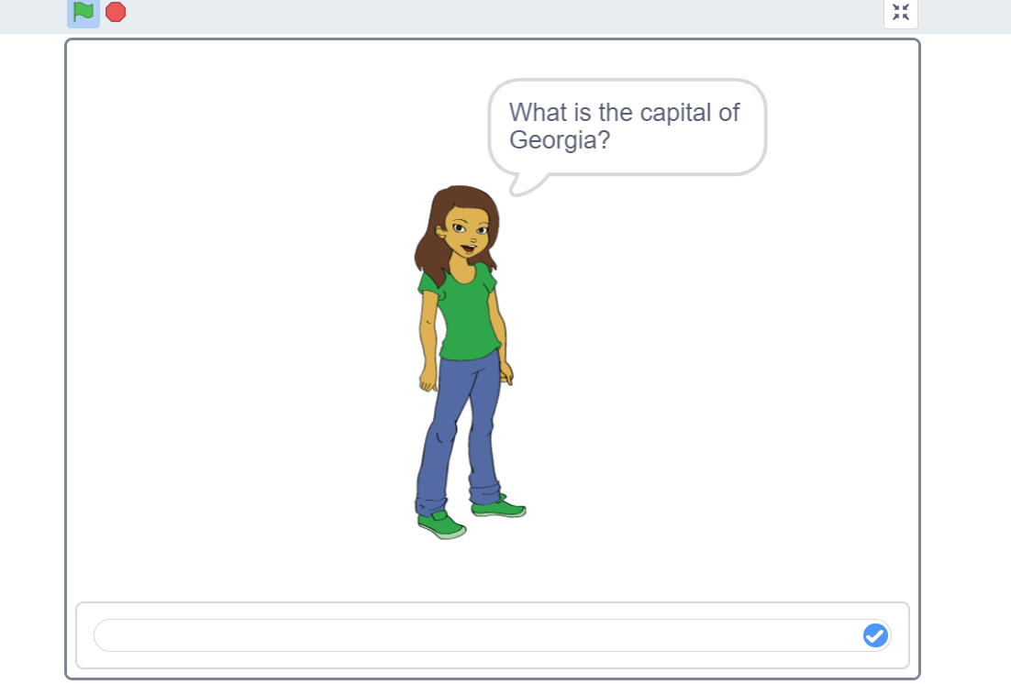
Step 5
Save your project and download the file to submit to your instructor using the File menu.
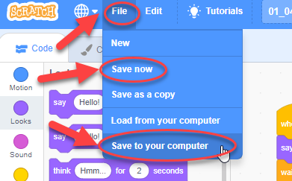

Optional Coding Challenge!
- Can you add a scoring system?
- Would you like to remove points for incorrect scores?
- Would you like to add sound effects if the player achieves a score of 10?
- Would you like to add sound effects if the player gets the answer wrong?
- What else can you add to your quiz game project?
Grading Rubric

Categories | Excellent | Good | Needs Improvement
Program Design | 11–20 pts.  Work contains all required elements:  - includes one sprite that is not the default sprite  - includes a background | 6–10 pts.  Work contains most of the required elements:  - includes one sprite that is not the default sprite  - includes a background | 0–5 pts.  Work contains few of the required elements:  - includes one sprite that is not the default sprite  - includes a background
Program Content | 11–20 pts.  Work contains all required elements:  - includes a variable to record user input  - includes conditional statements to determine what to do with the user’s answer  - includes feedback if the answer is correct or incorrect | 6–10 pts.  Work contains most of the required elements:  - includes a variable to record user input  - includes conditional statements to determine what to do with the user’s answer  - includes feedback if the answer is correct or incorrect | 0–5 pts.  Work contains few of the required elements:  - includes a variable to record user input  - includes conditional statements to determine what to do with the user’s answer  - includes feedback if the answer is correct or incorrect
Program Performance | 8–10 pts.  Work contains all required elements:  - runs correctly  - contains no syntax or runtime errors  - produces the expected results | 4–7 pts.  Work contains most of the required elements:  - runs correctly  - contains no syntax or runtime errors  - produces the expected results | 0–3 pts.  Work contains few of the required elements:  - runs correctly  - contains no syntax or runtime errors  - produces the expected results
Total points: 50

