How To Access Your AP World Textbook

Now that you’re a full-fledged member of the AP World team, it’s time to get you hooked up with the textbook. Your teacher and administration will handle the initial creation of your account, so let’s skip ahead.

In your web browser (we recommend Google Chrome given its sheer awesomeness), navigate your way to: https://bfw.thecopia.com. This is where you’ll input the login information provided by your teacher.

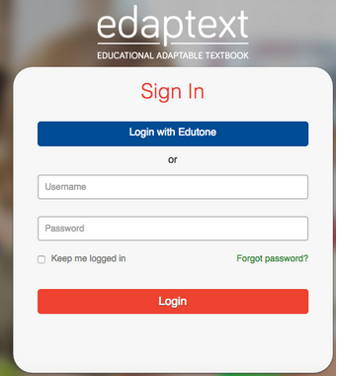

Once you’re successfully logged in, you should see a tile for each of the courses that uses Copia Class. Click on the one that says “AP World History.” Duh.
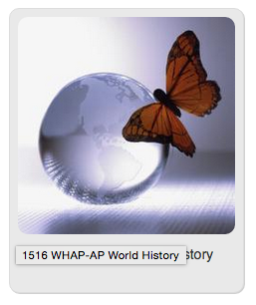
Within the course, you will see the option to add a book to your library. The textbook for our course is already there for you. Simply click on the book and then click the option to “Add to Course Library”.
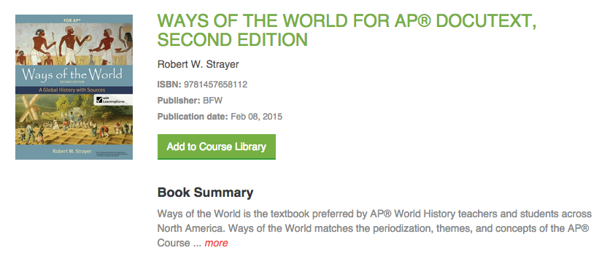

To download the app for your phone, tablet and computer, head to: https://bfw.thecopia.com/app.html#/ereaders. Here, you will be able to select the Operating System (OS) that you want to use (iOS for iPhone and iPad, Android for nearly everything else) and follow the links. Or click the “Readers” button in the top right-hand corner. Or, just go to the App Store on your device and search for “Copia Class”.

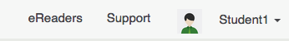

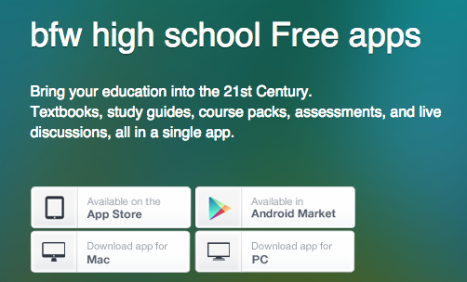

Once the app is downloaded onto the device(s) of your choosing, log in to it using the same username and password that you used at the website.

Now that your account is created and the eBook is downloaded, you’re all set to go! Be sure to reach out to Mr. Ledford (aledford@pasco.k12.fl.us or 813.294.8050) and let him know that you are set up. If you’re experiencing difficulty, you can call him for that too!

